# Overview

Derive a tangent plane equation to represent Drag as an approximation in the velocity and density dimensions. This might be expanded by linearizing around the CD domain as well using alpha as a state value. This linearization is only valid for the fall stage. It is to serve as part of a program to either calculate an LQR controller, or simulate a model for TensorFlow neural net training.

# Expected Flight Regime

* Velocity: 40 – 110 m/s (78 – 214 knots)
* Height: 0 – 4268 m (0 – 14,000 ft)
  + Implicit: Air density: ρSL(1.00 – 0.65)
* Angle of attack: (-10) – (10) deg

# Calculations – 1 Dimensional

The equation for a tangent plane is generalized below, where the finite series repeats for every dimension X, Y, Z, and so on…:

$$f_{approx}=f\left({\hat{P}}_{0}\right)+\sum{\left(x-x_{0}\right){\frac{∂f}{∂x}}_{@\hat{P_{0}}}}$$

Where:

* f_approx – The approximate value and linearized function
* f(~) – The original function being approximated
* vec(P0) – A vector with all of the initial dimension points (x0,y0,z0,…etc.)

For the necessary calculations it will be easier to treat the height variable as a density ratio relative to sea level. This will allow me to vary the sea level density for different weather and ASL values. The original drag equation and its’ derivation is as follows:

$$D= \frac{1}{2}S_{A}C_{D}\left(α\right)ρ\left(h\right)v^{2}$$

$$D= \left(\frac{S_{A}C_{D}ρ_{SL}}{2}\right)\left(\frac{ρ}{ρ_{0}}\right)v^{2}$$

Where:

* D – Drag force
* S_A – Surface area
* C_D – drag coefficient
* ρ_SL – Sea level density
* ρ/ρ0 – density ratio at some height relative to a reference density (In our case, ISA sea level density)
* v – Velocity

The derived version of the initial equation lumps all of the constant values into one variable (for now we will assume C_D to be constant and re-evaluate it later). The air density ratio is one dimension, which varies with height, and v^2 is the 2nd dimension we are linearizing around. For simplicity, the density ratio will furthermore be denoted as “S”. For further simplicity the constant values will be lumped into a variable denoted as “β”. See below…

$$S= \left(\frac{ρ}{ρ_{0}}\right)$$

$$β= \left(\frac{S_{A}C_{D}ρ_{SL}}{2}\right)$$

$$D= βSv^{2}$$

We can ascend one more level of abstraction by the following:

$D^{*}=Sv^{2}$, $D= βD^{*}$

Now we must only linearize D*, and plug it into the drag equation to approximate drag given a craft designed with β parameters.

$\frac{∂D^{*}}{∂S}= v^{2}$, $\frac{∂D^{*}}{∂v}=2Sv$

The flight regime is already planar, shown below. High speeds are more dominant in non-linearizing the function than density changes due to the velocity value exponent.

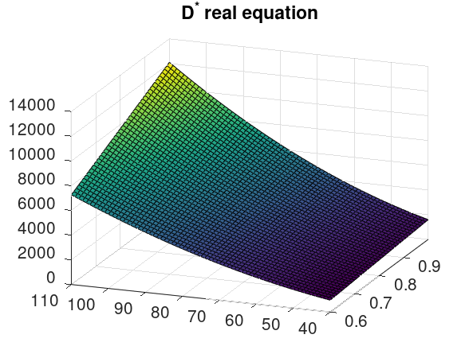

We can add a bias variable B to the equation to better capture this nonlinearity in our inevitable approximation. We can computationally calculate the B variable using a method similar to the least squared regression algorithm. Thus, the planar equation is as follows…

$$f_{approx}=B+f\left({\hat{P}}_{0}\right)+\sum{\left(x-x_{0}\right){\frac{∂f}{∂x}}_{@\hat{P_{0}}}}$$

Given the flight regime, it is most appropriate to select vec(P0) as the middle of all dimensions. Vec(P0) = <0.825, 75>. See below.

|  |  |
| --- | --- |
| Variable | Value |
| Vec(P0) | <0.825, 75> |
| df/dS | 5625 |
| df/dv | 123.75 |
| F(P0) | 4641 |

This approximation is decent as-is, but if we calculate B by finding the value which minimizes the square of the local error values, we get B = +367. Therefore…

$$D_{approx}^{*}=5625\left(S\right)+123.75\left(v\right)-8914$$

Because our state variables include height (h) and not S, it would be smart to also linearize S around the variable h. Instead of calculating the tangent line for S, the least squares regression is used. Additionally, under the North-East-Down convention, any altitude above sea level is actually considered negative, and a descent towards the ground is considered to be positive velocity. We will change the signs of the equation to accommodate this convention. The linearized equation plugged into S in units of meters and distributed resulting in the equation:

$$D_{approx}^{*}=-0.45\left(h\right)+123.75\left(-v\right)-3328$$

Where:

* Dapprox* - The approximated function
* h – height above sea level in meters
* v – velocity in meters per second

This is an important step in our function! We have linearized around the dimensions of height and velocity. If we stopped here, this would be enough to create a 1 dimensional falling simulation. Such a simulation however, is not very useful, because it disregards wind and an initial horizontal velocity. However, for the sake of testing our equation, here is a graph showing velocity over time using the linearized equation.

$$\frac{dv}{dt}=9.81+\frac{β}{m}\left(-0.45\left(h\right)+123.75\left(-v\right)+3328\right)$$

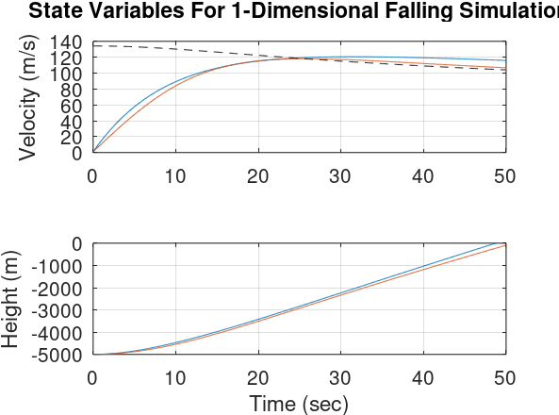

Notice how the initial condition for height is negative and the velocity is increasing in value. As a reminder, this is because of the North-East-Down convention. The blue line represents our approximation function. The red line is a more realistic Euler’s method ODE solution using the original drag equation. The dashed black line is the real terminal velocity given the flight parameters for the height of Euler’s method solution. We can see very clearly that the approximation is quite close to Euler’s method, and varies only by at most ~10 m/s. This error can propagate in the form of significant height error over time, but our free-fall is not expected to last longer than 1 minute, so this is of little concern. The state space form of our approximated model is shown below. This overly simplistic model is simply an A matrix due to a lack of disturbance or control input.

$$\left[\begin{matrix}0 \\ v \\ a\end{matrix}\right]=\left[\begin{matrix}0 & 0 & 0 \\ 0 & 0 & 1 \\ 9.81+3328\frac{β}{m} & -0.45\frac{β}{m} & -123.75\frac{β}{m}\end{matrix}\right]\left[\begin{matrix}1 \\ h \\ v\end{matrix}\right]$$

# Calculations – Full Spatial